Gabriel Chetty

UCT  CPT

CSC2001 Assignment 1 report

**Table of Contents**

OO design – page 2

Testing – page 3

Creativity – page 7

**OO Design**

I’ve created a total of 5 classes:

* GenericsKbArrayApp
  + GenericsSearch
* GenericsKbBSTApp
* GenericBinaryST
* TreeNode

GenericsKbArrayApp and GenericsKbBSTApp are the main functions for the array and bst respectively. GenericSearch contains the search methods, getIndex, as well as a get Confidence and fullSearch method.

TreeNode class contains the nodes , left and right and the data stored in them. GenericBinarySt consists of the search function as well as its helper, the insert function, the Traversal function, similar search function, delete function, min function (helps delete) and searchfull function as well as all their helpers. TreeNode provides the nodes for GenericBinaryST to work with.

**Array App:**

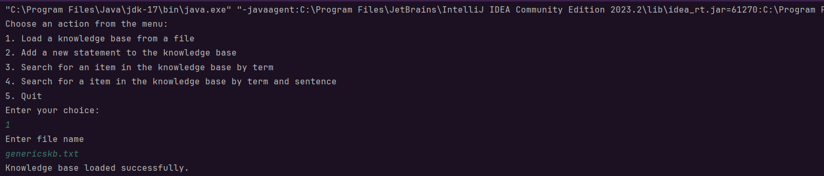Case 1:

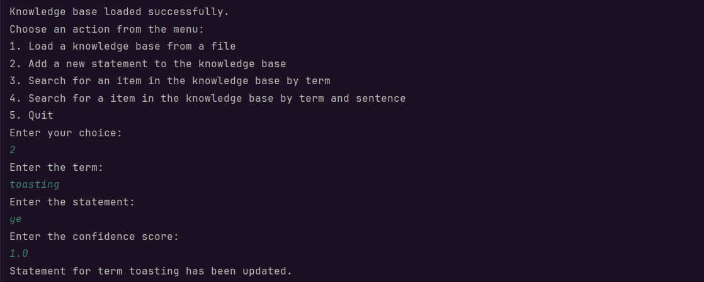Case 2:

Case 3:

:

Case 4:

Case 5:

**BST App:**

Case 1:

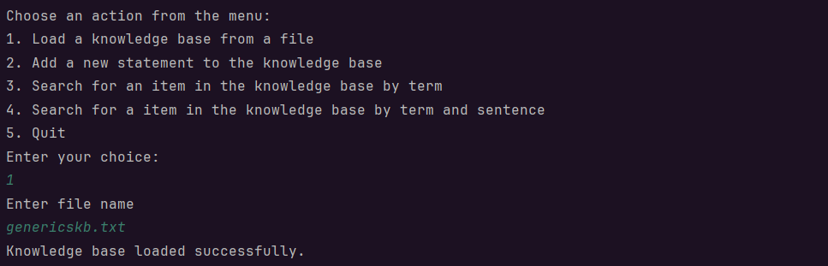

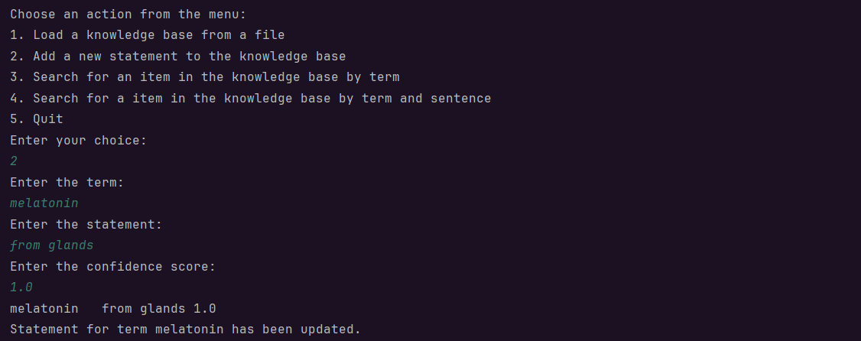Case 2:

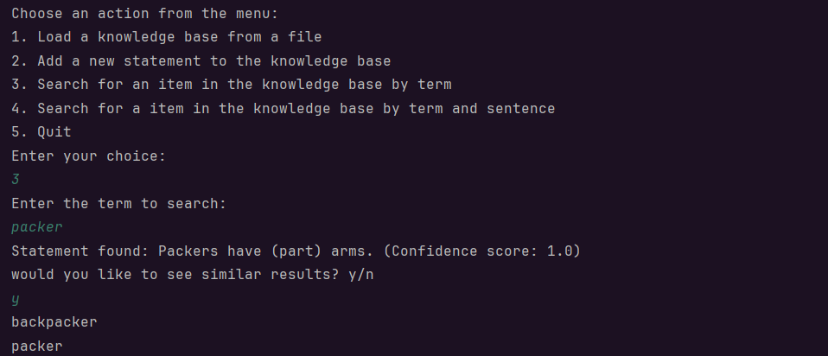Case 3:

Case 4:

Case 5:

**Creativity:**

I’ve enhanced the search functionality to search for similar terms . such as terms that contain other terms (e.g. “packer” and “backpacker”).

I’ve added code to account for input mismatch when entering letters instead of numbers for the actions in menu, to prevent errors.

In array app I’ve added a function to action 2 to insert a line into the array if it is not found (and therefore not updated).

**Git log:**

0: commit f4aad32aa7d0f82be70e98a750075fa49e837aa2

1: Author: nRagos <gchetty241@outlook.com>

2: Date: Fri Mar 8 18:22:03 2024 +0200

3:

4: report and makefile

5:

6: commit 5ffc1992367770b4bcc4e7fe07a0c9f703f87487

7: Author: nRagos <gchetty241@outlook.com>

8: Date: Fri Mar 8 17:37:41 2024 +0200

9:

...

85: Author: nRagos <gchetty241@outlook.com>

86: Date: Wed Mar 6 21:51:02 2024 +0200

87:

88: redo

89:

90: commit a11b3b527822829194b0095cdf51754c1f3def2a

91: Author: nRagos <124688834+nRagos@users.noreply.github.com>

92: Date: Wed Mar 6 20:13:09 2024 +0200

93:

94: Initial commit